**GANPAT UNIVERSITY**

 

Name : Desai Yatrik

Enrollment No. : 22162101003

Branch : CBA

Batch : 51

Practical : 12

Subject : Microservices

Semester : 5

**Pre-Requisites :**

1. Docker should be installed in our system
2. Node js should be installed
3. Account on docker hub
4. Knowledge of docker commands
5. Mongodb should be installed

**Practical 12 :**

Develop a Node.js Express application that provides RESTful APIs to manage student data, allowing operations such as retrieving, adding, updating, and deleting student records. Finally build an image of your application and run it as a docker container. Also upload the image to Docker Hub.Features : Retrieve a list of all students. : Add a new student to the database.

Retrieve a specific student by ID. : Update an existing student's information by ID.

Remove a student from the database by ID.

Data Structure: Each student record should include: id: Unique identifier (integer) , name: Student's name (string) , age: Student's age (integer)

Image name should be following format: Your_docker_hub_usename/Repository name.

Container name: Task_Practical_12

Attach the screenshots and pull command to pull your image from docker hub in the documentation

**Screenshots :**

1. Code for creating database Student_records and collection Students

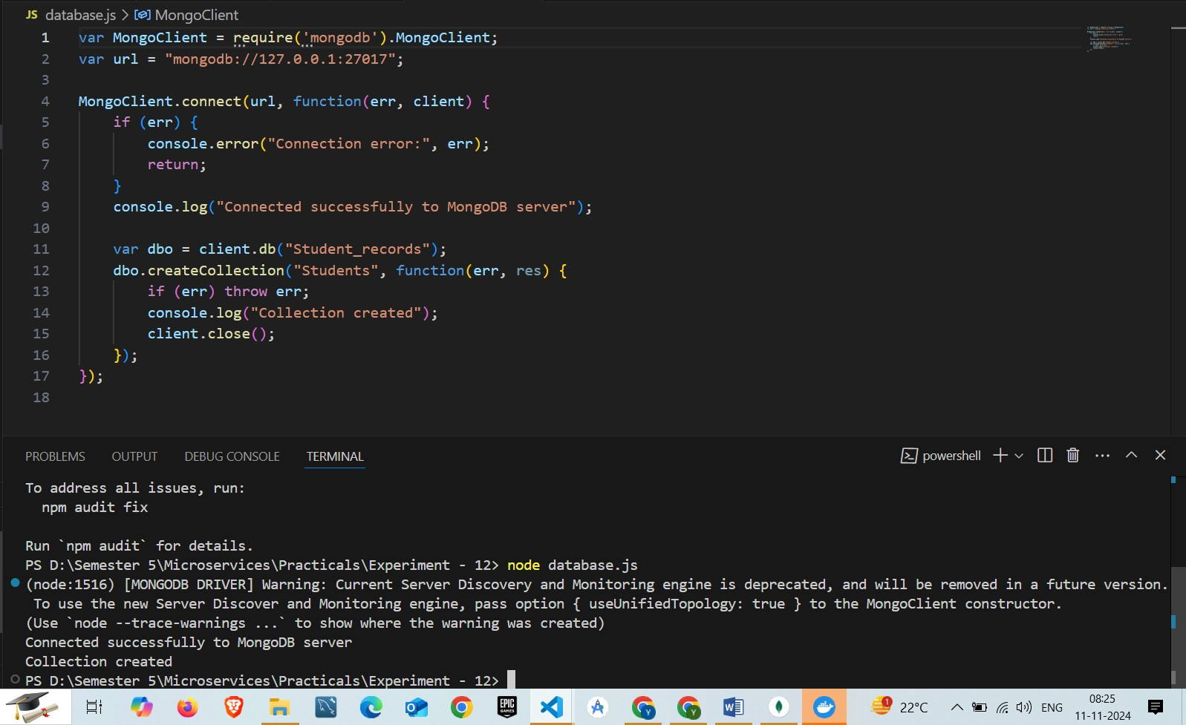

2. Successfully created the collection and database

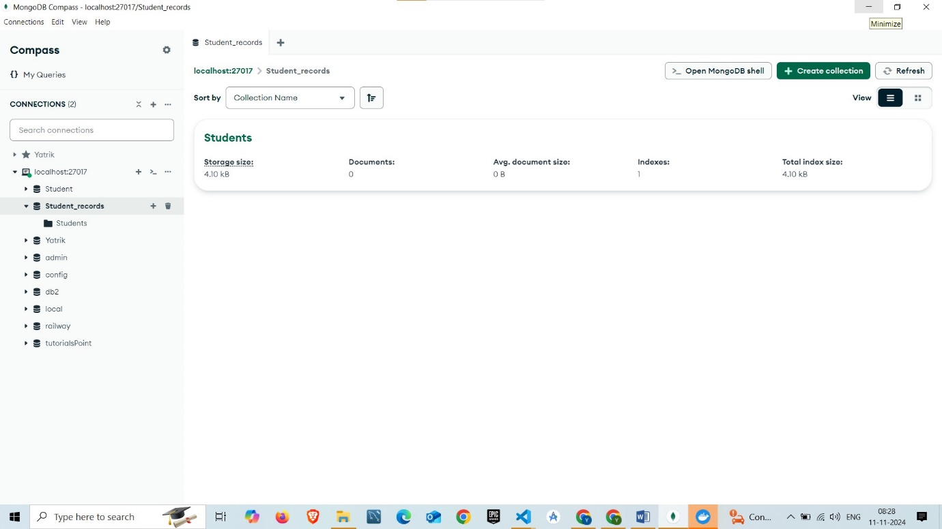

3. Inserting student records into collection Students

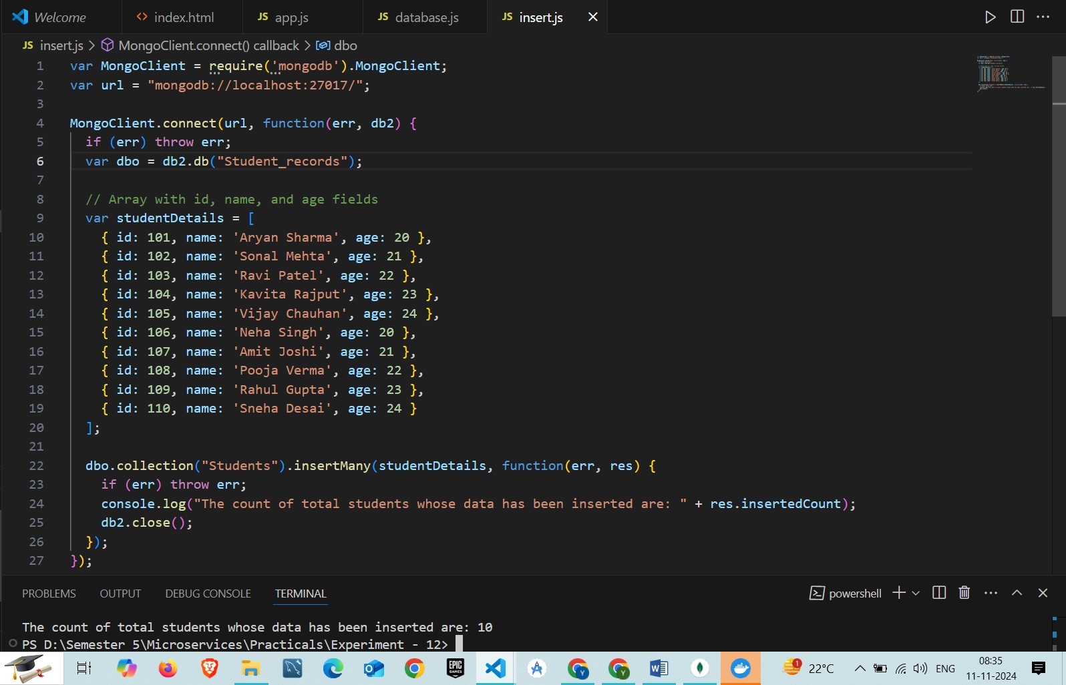

4. Successfully inserted 10 records into collection

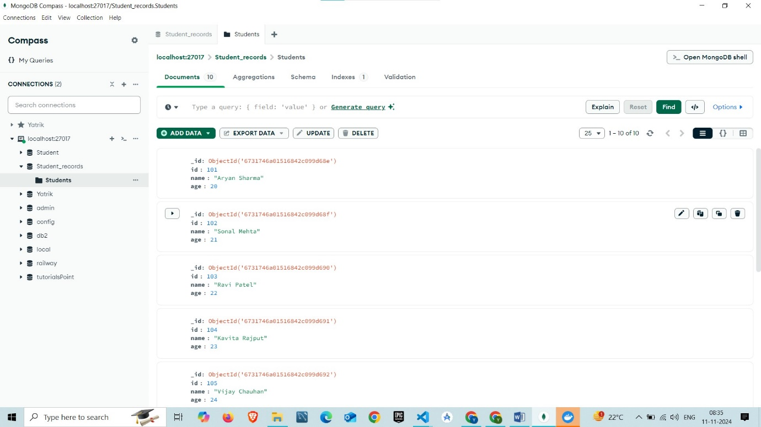

5. Code to simply connect with database and providing schema

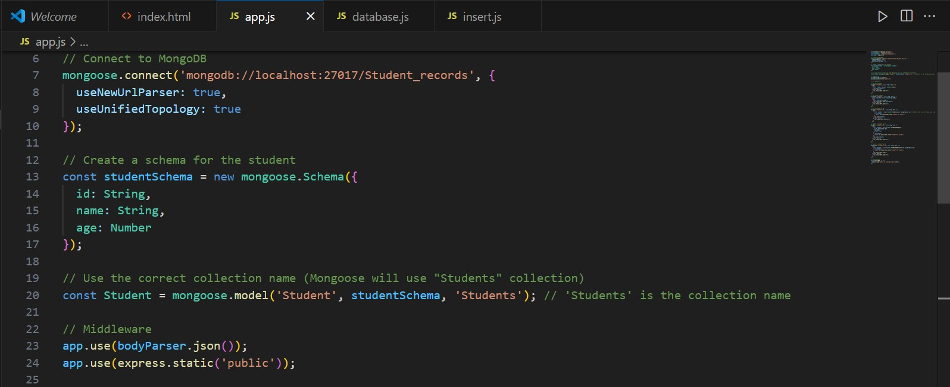

6. Code for retrieving all students

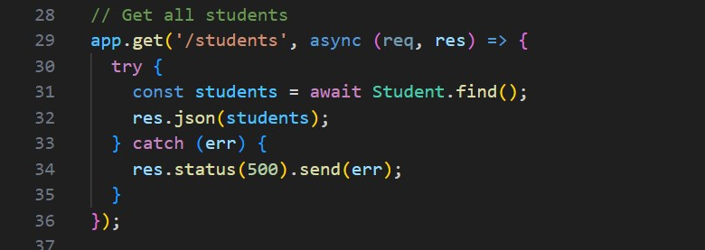

7. Code for adding new student into database

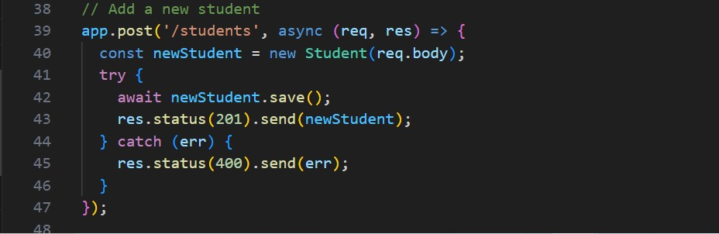

8. Code for retrieving student by specific id

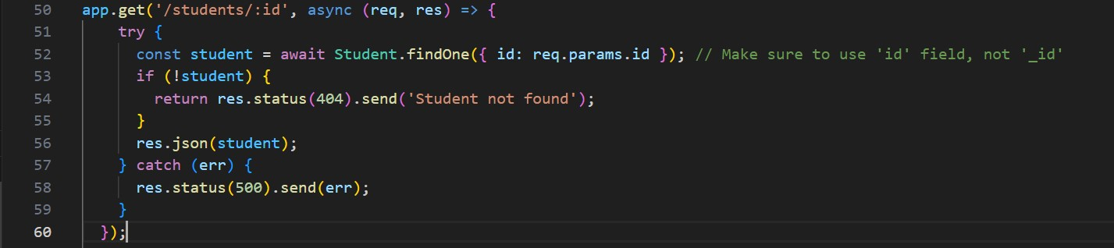

9. Code for updating information of students

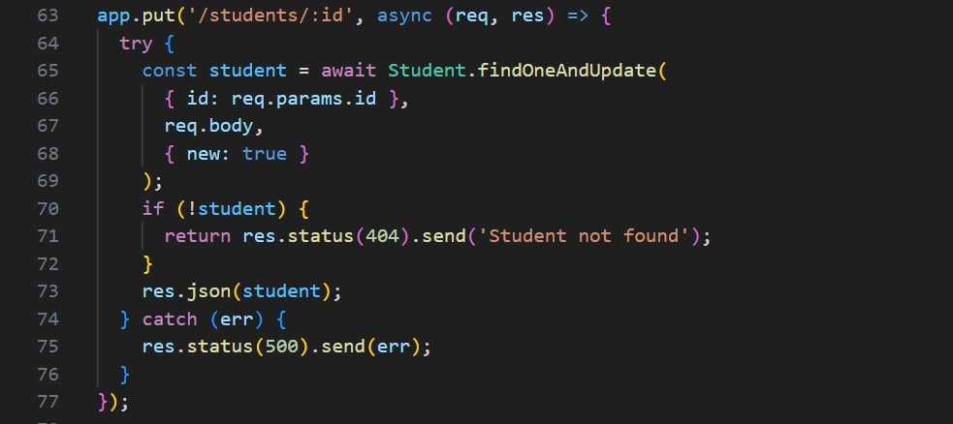

10. Code for removing student based on specific id

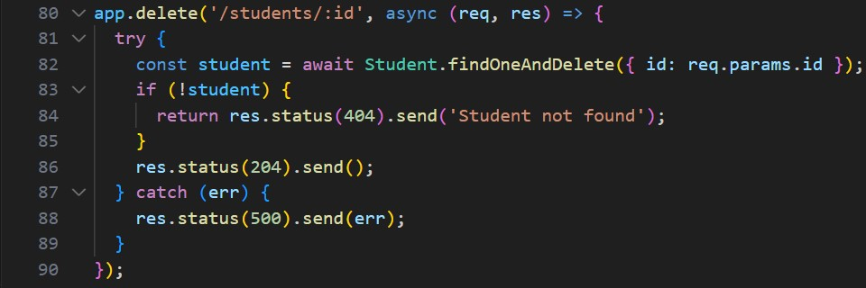

11. Dockerfile for our node js application

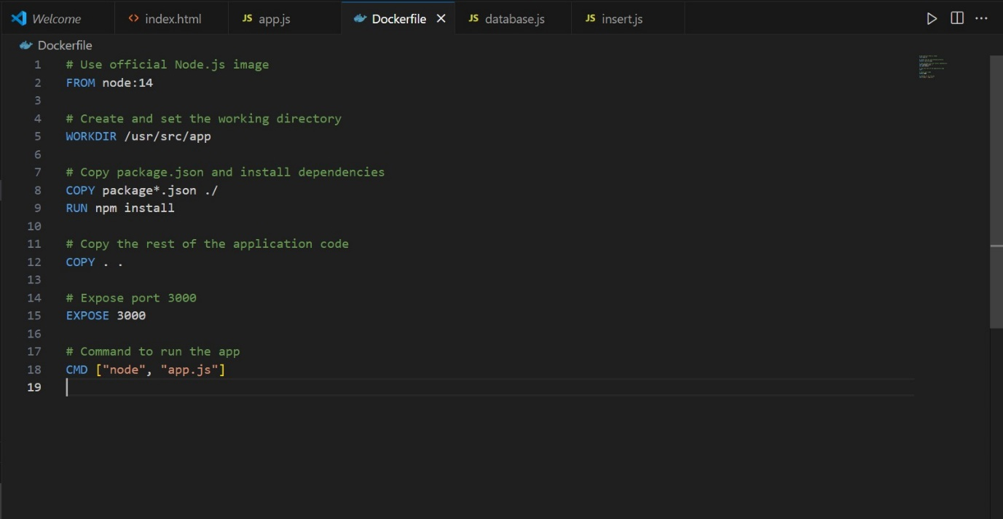

12. Command : docker build -t yatrik1204/student_management .

=> Building an image yatrik1204/student_management

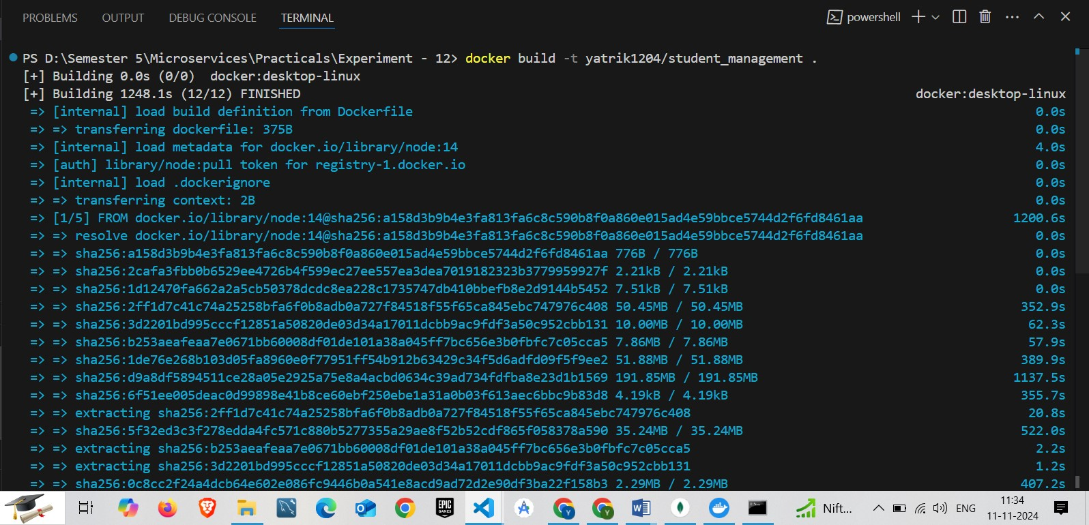

13. Successfully created an image on docker

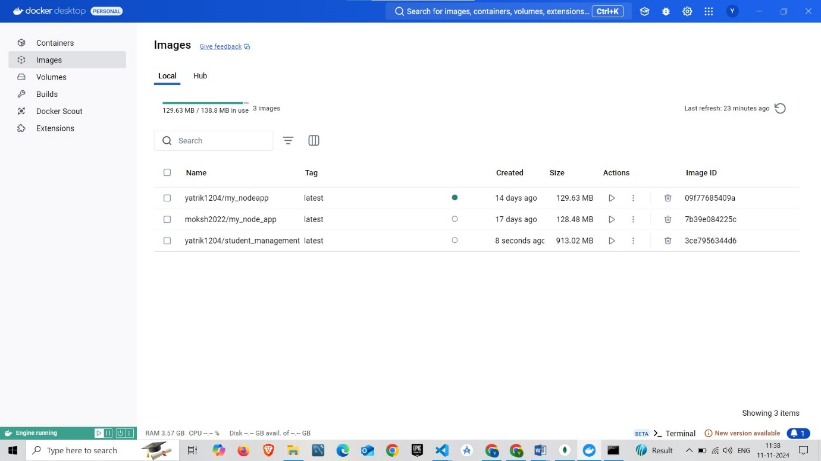

14. Command : docker run -d -p 3000:3000 --name Task_Practical_12 yatrik1204/student_management

=> it will create a container named Task_Practical_12 from image yatrik1204/student_management

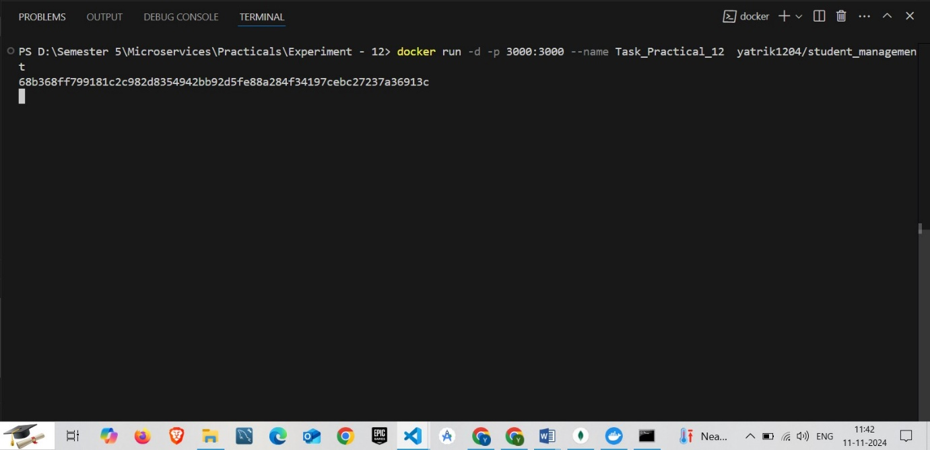

15. Successfully Created Task_Practical_12 Container on Docker

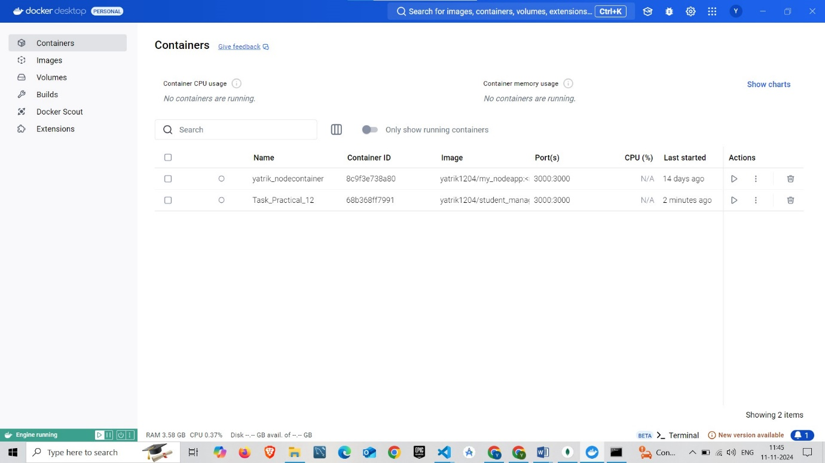

16. Command : docker push yatrik1204/student_management

=> it will push the image yatrik1204/student_management

